**NAME: OMOBOLA OLAJIDE**

**EMAIL: omobola.olajide@womentechsters.org**

**PRACTICAL ACTIVITY WEEK 6-WIRESHARK**

**QUESTIONS**

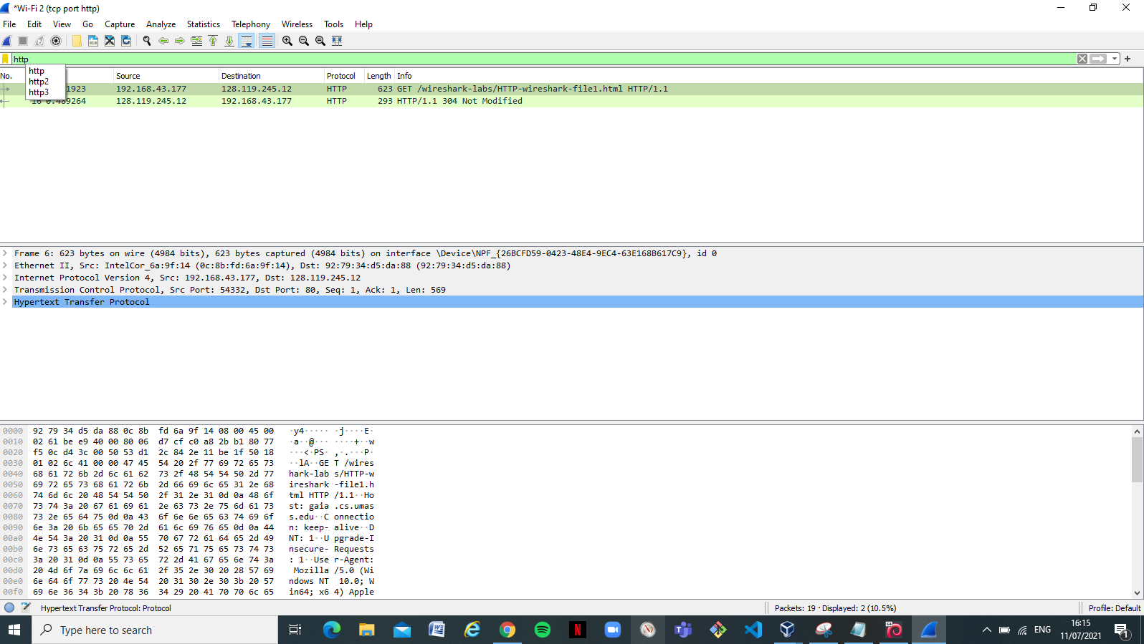

1. Is your browser running HTTP version 1.0 or 1.1? What version of HTTP is

the server running?

**Answer**: The Brower is running HTTP 1.1 and the server is running

1.png

2. What languages (if any) does your browser indicate that it can accept to the server? In the captured session, what other information (if any) does the browser provide the server with regarding the user/browser?

**Answer**: It indicates that it can accept an en-US language (English).

Language.png

3. What is the IP address of your computer? Of the gaia.cs.umass.edu server?

**Answer**: The Ip address of my computer is 192.168.43.177 and that of the gaia.cs.umass.edu server is 128.119.245.12

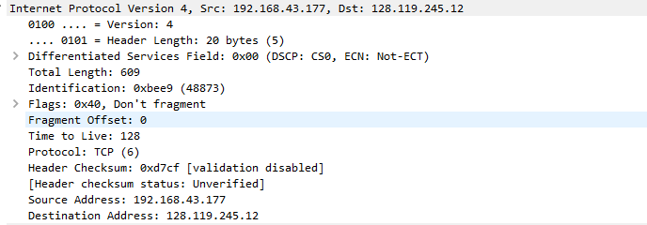

4. What is the status code returned from the server to your browser?

**Answer**: 200 OK is the status code returned to the browser.

5. When was the HTML file that you are retrieving last modified at the server?

**Answer:** Sunday 11th July,2021

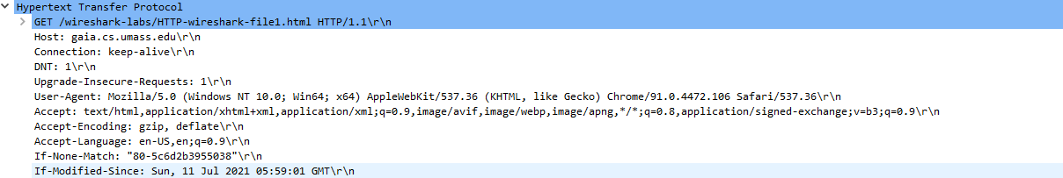

6. How many bytes of content are being returned to your browser?

**Answer**: 128 bytes is being returned to the browser

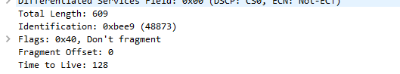

7. By inspecting the raw data in the packet content pane, do you see any http

headers within the data that are not displayed in the packet-listing window?

If so, name one.

**Answer** : No. The raw data appears to match up exactly with what is shown in the packet-listing window.

Task A: For questions 1-7, first write a brief but precise answer for each of the

above questions, then write a (combined) paragraph explaining and discussing your

observations from the above practice questions. Note that your answer may benefit

from explaining and/or referring to some of your observations explicitly.